CSA1005 - SOFTWARE ENGINEERING
P. Greeshma (192424418)
192424418.simats@saveetha.com

LAB EXPERIMENTS
EXP – 11
Deploying a Static Website using Docker

Aim:
To containerize a simple static website and deploy it using Docker.
Procedure:
- Create a basic index.html file for the static website.
- Write a Dockerfile that uses the Nginx web server to host the website.
- Build the Docker image using the Dockerfile.
- Run a Docker container from the created image.
- Open a web browser and access the website using the container’s local address.
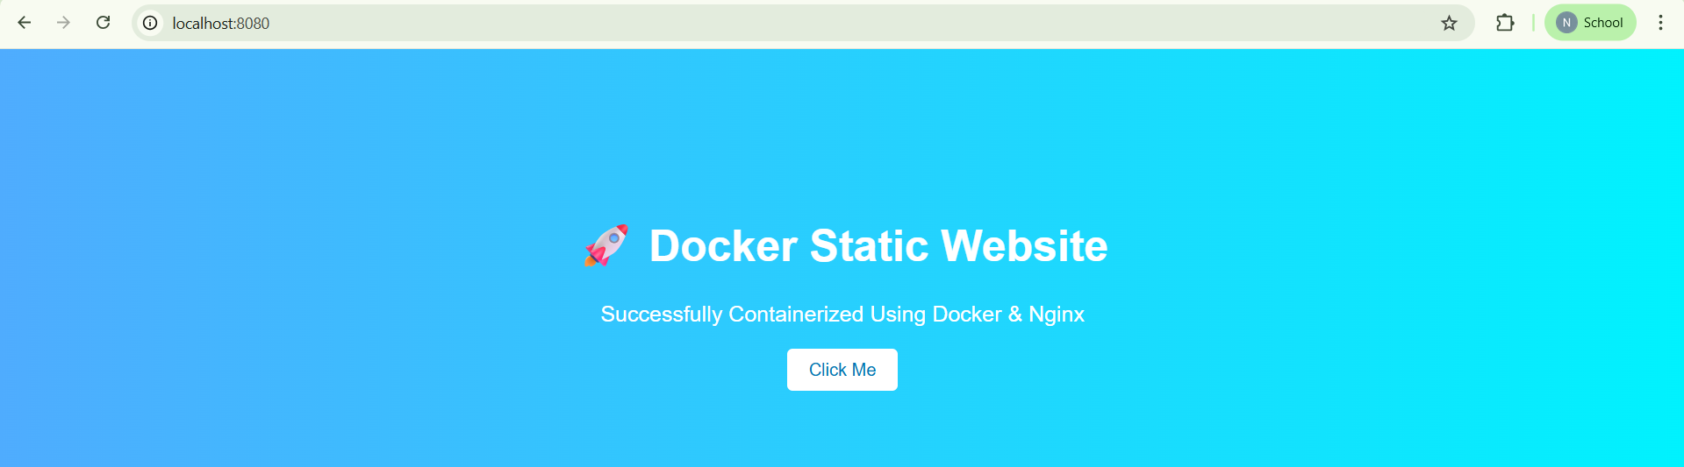

Result:
The static website was successfully containerized and deployed using a Docker container, and it was accessible through the web browser.
EXP- 12
Flask API with Docker & Kubernetes
Aim:
To containerize a Flask API using Docker and deploy it on a Kubernetes cluster for scalable access.
Procedure:
- Developed a simple Flask API application.
- Created a Dockerfile to containerize the Flask application.
- Built the Docker image and pushed it to a container registry (e.g., Docker Hub).
- Defined Kubernetes Deployment and Service configurations using YAML files.
- Deployed the application to the Kubernetes cluster using kubectl commands.
- Exposed the application externally using a NodePort service.
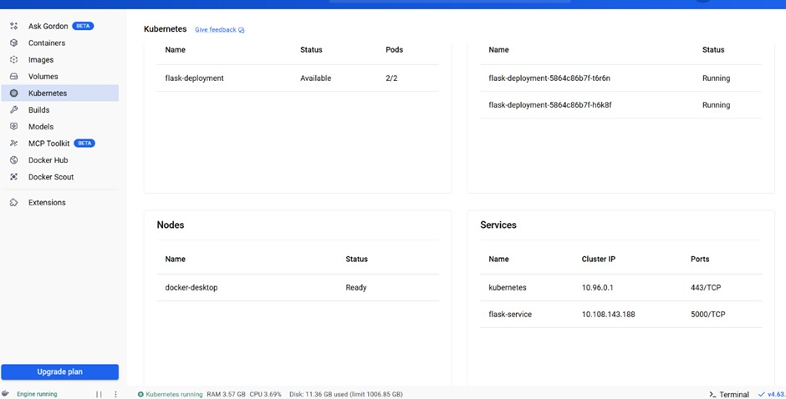
Result:
The Flask API was successfully containerized, deployed, and accessed through the Kubernetes cluster using NodePort, ensuring scalability and efficient service management.
EXP- 13
CI/CD using Jenkins
Aim:
To automate the process of building and deploying applications using Jenkins as a Continuous Integration and Continuous Deployment (CI/CD) tool.
Procedure:
- Installed and configured Jenkins on the system/server.
- Created a Dockerfile to containerize the application.
- Developed a Jenkinsfile to define the pipeline stages (build, test, deploy).
- Configured a webhook to trigger the pipeline automatically on code commits.
- Executed the pipeline in Jenkins to perform automated build and deployment.
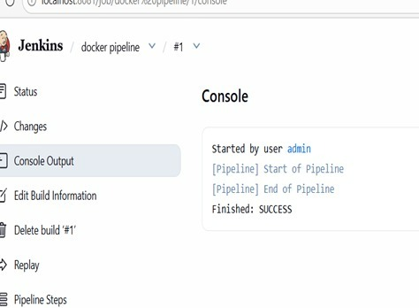
Result:
The CI/CD pipeline was successfully set up and executed, enabling automatic build and deployment of the application whenever changes were committed to the repositor
EXP- 14
Continuous Deployment with GitHub Actions
Aim:-
To implement an automated workflow for building Docker images and deploying the application using GitHub Actions.
Procedure:-
- Initialized a new repository on GitHub to manage the project code.
- Added a Dockerfile to define the containerization process of the application.
- Created a GitHub Actions workflow YAML file to automate build and deployment steps.
- Committed and pushed the code to the repository to trigger the workflow.
- Monitored the workflow execution and confirmed successful automatic deployment.
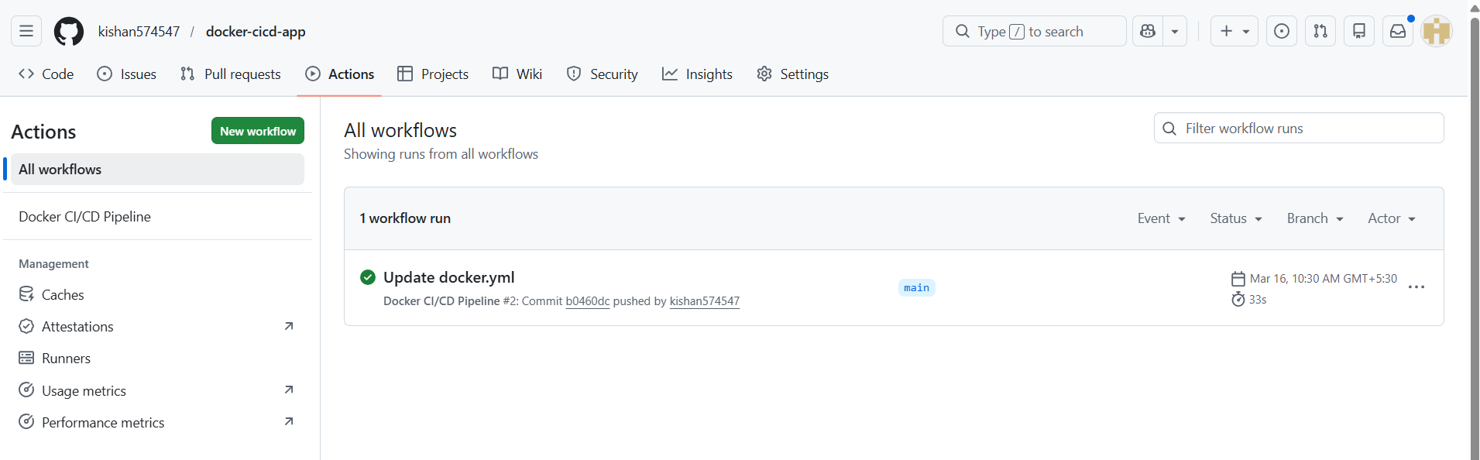
Result:-
The application was successfully built and deployed automatically through the GitHub Actions pipeline whenever code changes were pushed to the repository.

EXP- 15
GitHub Version Control
Aim:-
To establish and manage a version control workflow using GitHub.
Procedure:-
- Created a new repository on GitHub to store project files.
- Established multiple branches to manage different features or updates.
- Performed modifications and committed changes to the respective branches.
- Initiated pull requests to merge changes into the main branch.
- Handled and resolved any merge conflicts that occurred during integration.
- Updated the README file to document the project details and workflow.
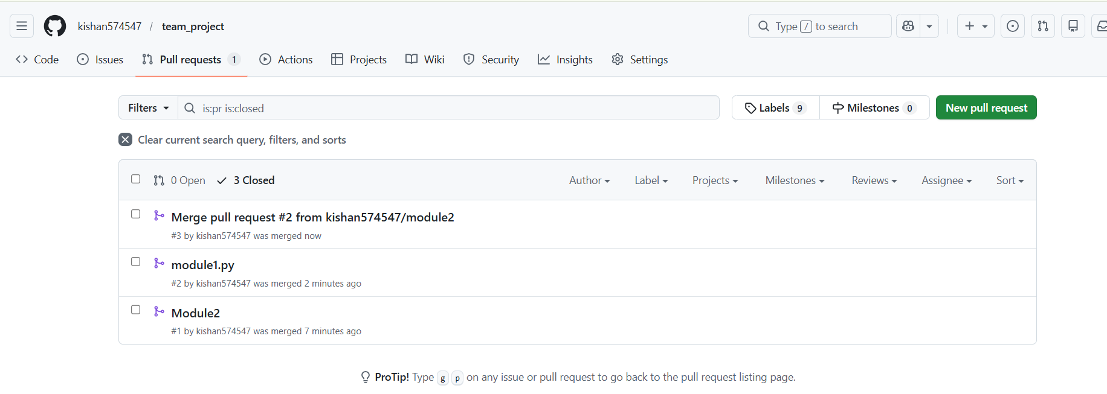

Result:-
The version control workflow was successfully implemented, enabling efficient tracking, collaboration, and management of code changes.

EXP- 16
Containerize Flask To- Do App
Aim:-
The objective of this experiment is to containerize a Flask-based To-Do application using Docker and deploy it by pushing the image to Docker Hub.
Procedure:-
- Develop a simple To-Do web application using the Flask framework in Python.
- Create a Dockerfile that specifies the base image, dependencies, and commands required to run the Flask application.
- Build a Docker image from the Dockerfile using the Docker build command.
- Run the Docker container from the created image to host the Flask application.
- Tag the Docker image and push it to Docker Hub so that it can be accessed and deployed on other systems.
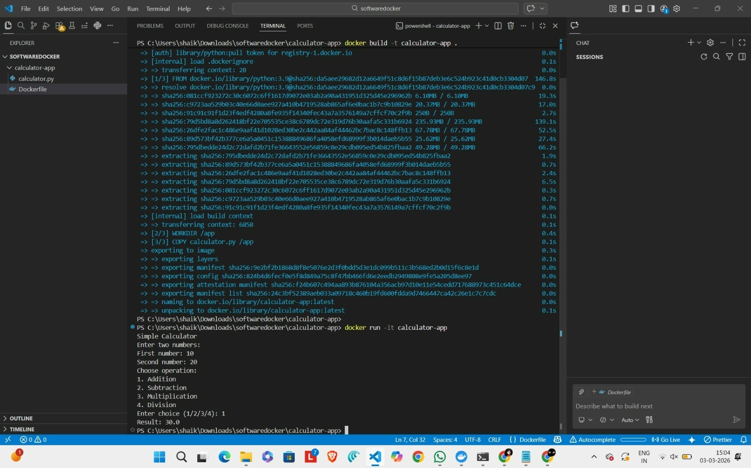

Result:-
The Flask To-Do application was successfully containerized using Docker, executed inside a container, and the Docker image was uploaded to Docker Hub for deployment and sharing.

EXP – 17
Pushing and Pulling Docker Images
Aim:
To understand how to upload a Docker image to Docker Hub and download it on another system.
Procedure:
- Create a Docker image for the application.
- Assign a proper tag to the created Docker image.
- Upload (push) the tagged image to Docker Hub.
- Download (pull) the same image on another system from Docker Hub.
- Run a container using the pulled Docker image.
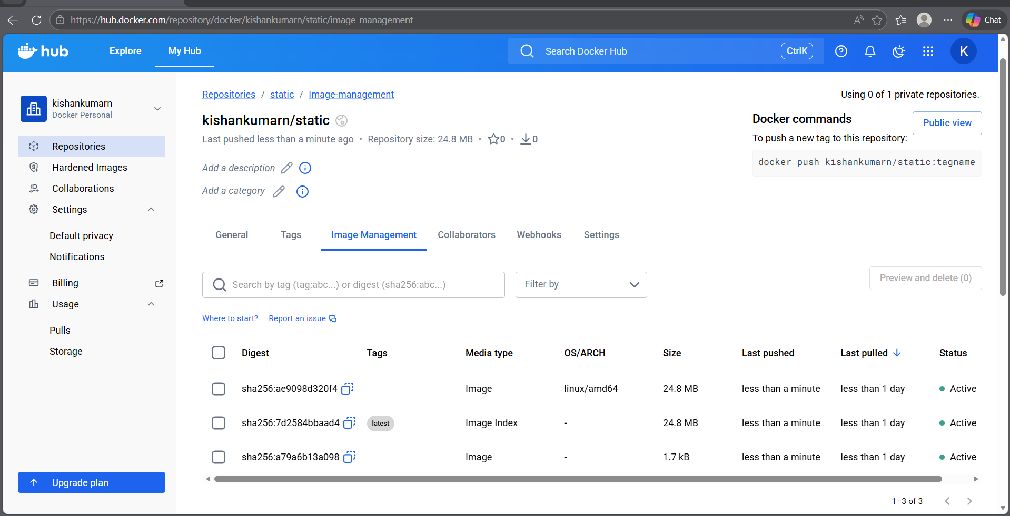
Result:
The Docker image was successfully pushed to Docker Hub and pulled on another system, and the container was executed successfully.

EXP- 18
Multi- Container App with Kubernetes
Aim:-
To deploy and manage a multi-container application using Kubernetes.
Procedure:-
- Developed separate containers for frontend, backend, and database components.
- Created Kubernetes YAML configuration files for deployment and services.
- Applied the configurations using kubectl to deploy the application.
- Observed and managed running pods to ensure proper functioning.
- Increased the number of frontend replicas to achieve scaling.
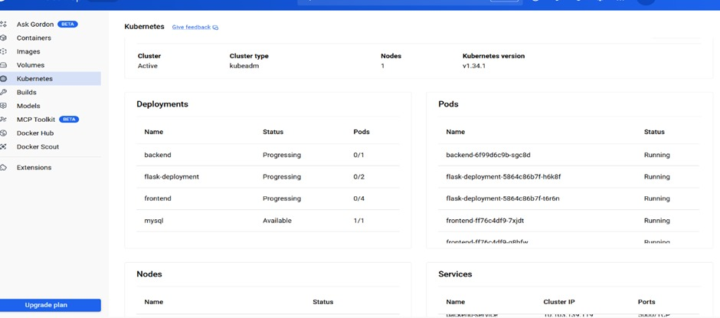
Result:-
The multi-container application was successfully deployed on Kubernetes, and scaling of components was achieved efficiently.
EXP-19
CI/CD with GitHub Actions
Aim:-
To automate the processes of testing and deployment using GitHub Actions.
Procedure:-
- Created a workflow YAML file to define the automation process.
- Included build and testing stages within the workflow configuration.
- Pushed the updated code to the repository to trigger the workflow.
- Monitored the execution and confirmed successful deployment.
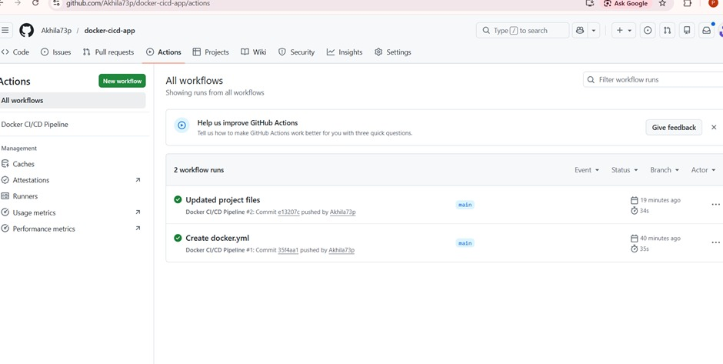
Result:-
The CI/CD pipeline was successfully executed, ensuring automated testing and deployment of the application.

EXP- 20
Create GitHub Repository
Aim:-
To create a GitHub repository and perform updates using version control operations.
Procedure:-
- Initialized a new repository on GitHub.
- Cloned the repository to the local system.
- Modified the README file with necessary project details.
- Committed the changes and pushed them back to the remote repository.
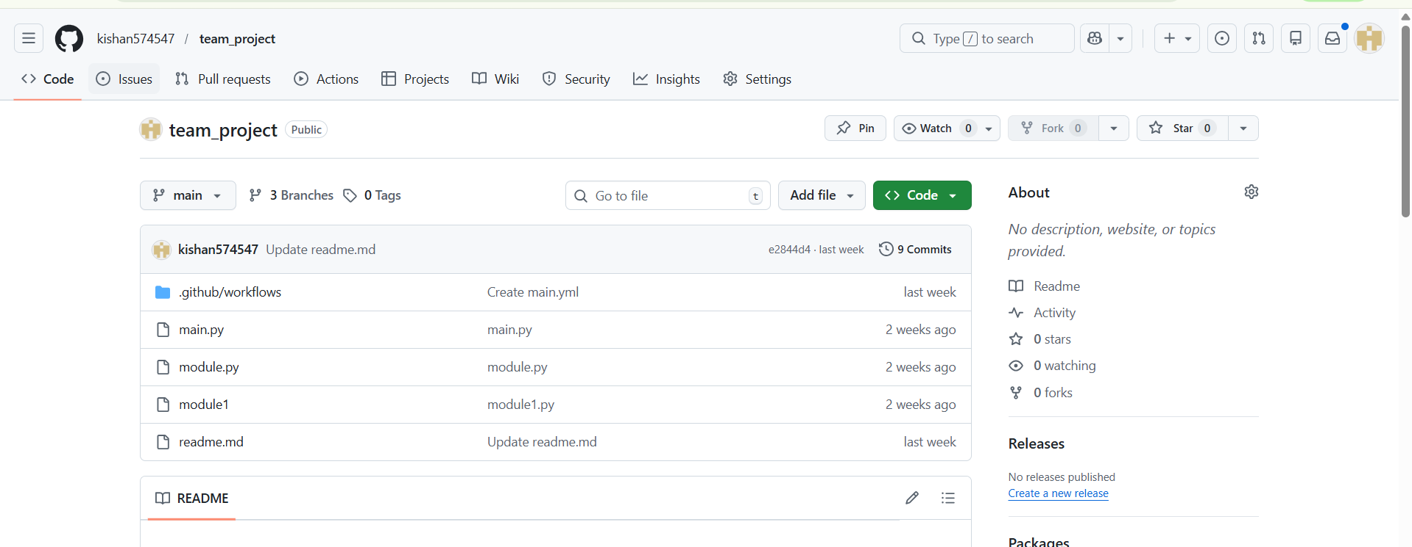

Result:-
The repository was successfully created and updated, with changes reflected on GitHub.

EXP-21
Clone & Modify Repository
Aim:-
To clone a GitHub repository and make modifications to its contents,by using git bash software.
Procedure:-
- Cloned the existing repository from GitHub to the local machine.
- Accessed and opened the required file from the project.
- Updated the content as per the requirement.
- Saved the modified file in the local repository.
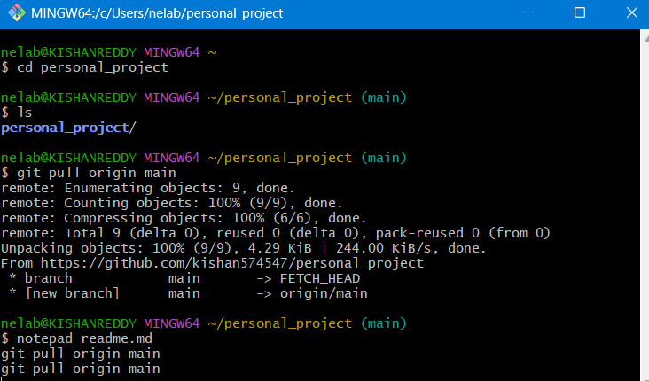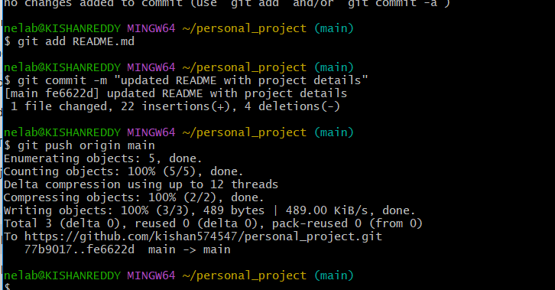

Result:-
The file was successfully edited and updated in the local repository.

EXP-22
Commit & Push Changes
Aim:-
To record changes locally and update them to a remote GitHub repository.

Procedure:-
- Added the modified files to the staging area.
- Committed the changes with an appropriate message describing the updates.
- Pushed the committed changes to the GitHub repository.
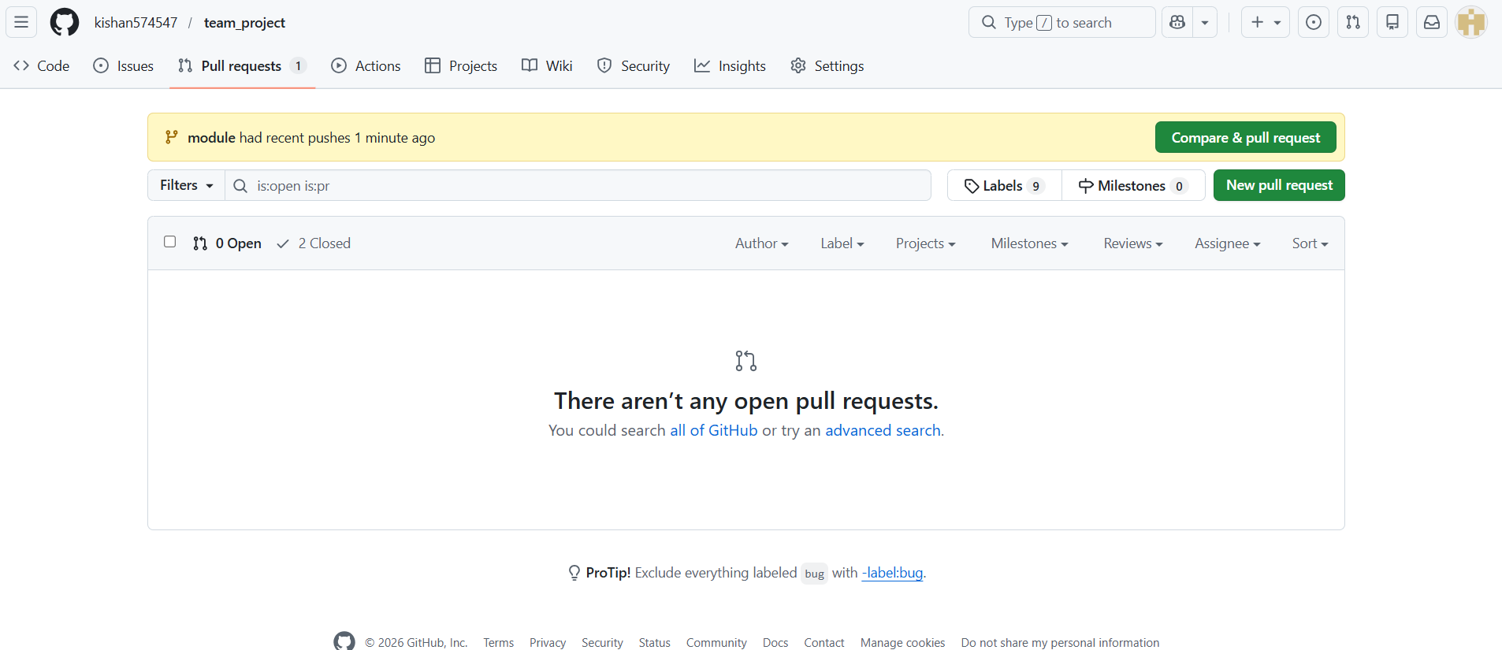

Result:-
The changes were successfully uploaded and reflected in the GitHub repository.
EXP-23
Pull Latest Changes
Aim:-
To synchronize the local repository with the latest updates from the remote repository.

Procedure:-
- Cloned the repository to the local system.
- Another collaborator made and pushed changes to the remote repository.
- Executed the git pull origin main command to fetch and merge updates.
- Checked and confirmed that the local files were updated accordingly.
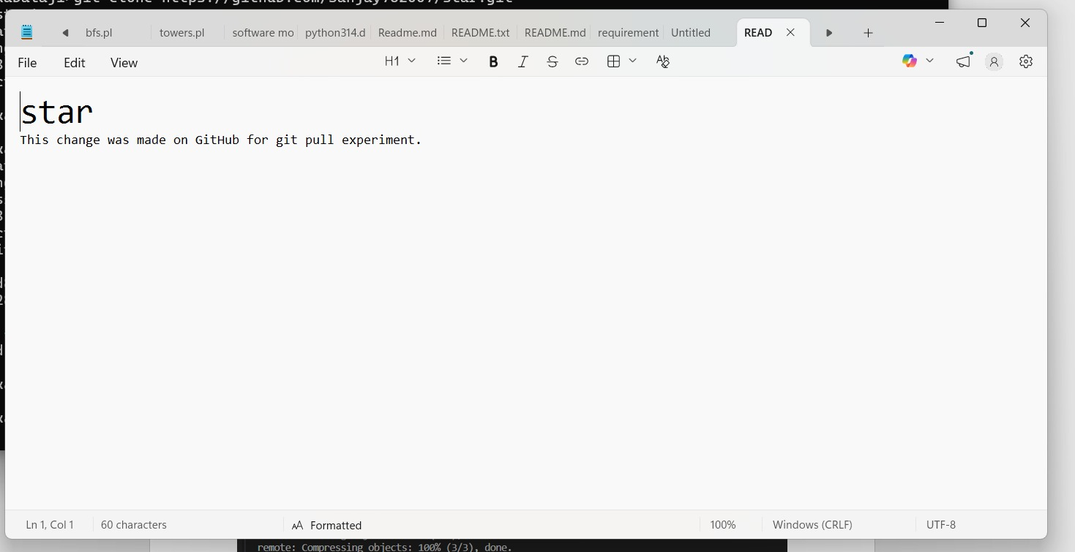
Result:-
The local repository was successfully updated with the latest changes from the remote repository.
EXP-24
Create Feature-Login Branch
Aim:-
To implement a login feature using Git branching techniques.

Procedure:-
- Created a new branch named feature-login for developing the login functionality.
- Added a new file login.py to implement the login feature.
- Committed the changes and pushed the branch to the remote repository.
- Raised a pull request to integrate the feature branch into the main branch.
- Reviewed and merged the branch after verification.
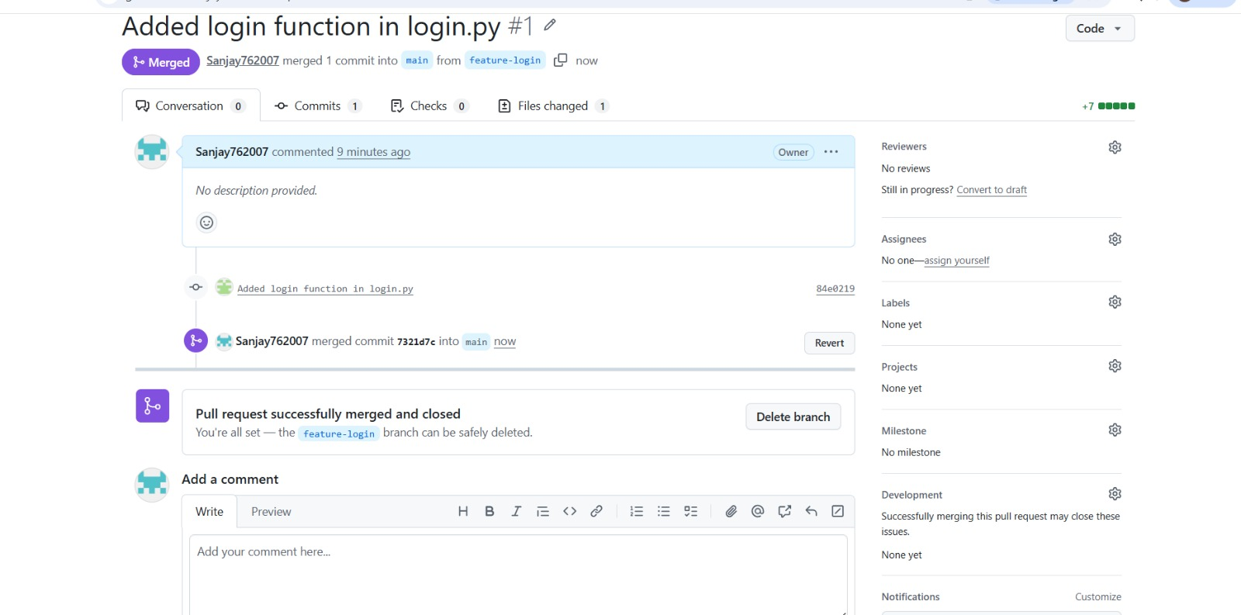

Result:-
The login feature was successfully integrated into the main branch using the Git branching workflow.
EXP-25
Fork & Implement Feature
Aim
To collaborate on a project using a fork-based workflow in GitHub.
Procedure
- Forked the original repository to create a personal copy.
- Cloned the forked repository to the local system.
- Created a separate branch to work on the new feature.
- Implemented the required feature in the project files.
- Pushed the changes to the forked repository.
- Submitted a pull request to merge the feature into the original repository.

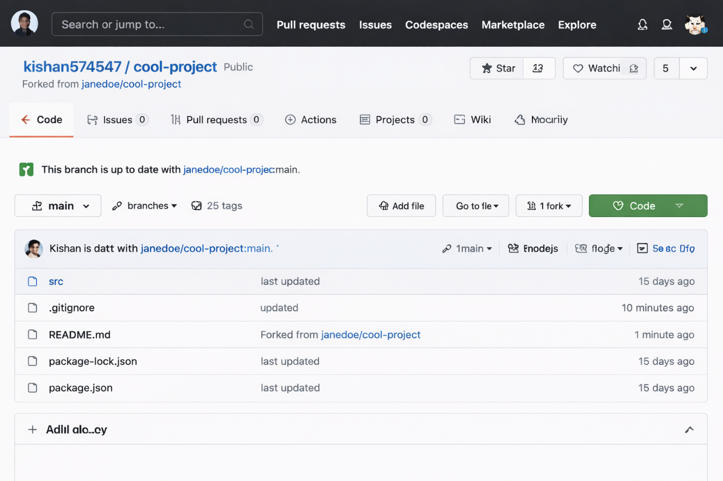
Result
The feature was successfully contributed to the original repository through a pull request using the fork-based workflow.

